Proof of independent prescriber qualification

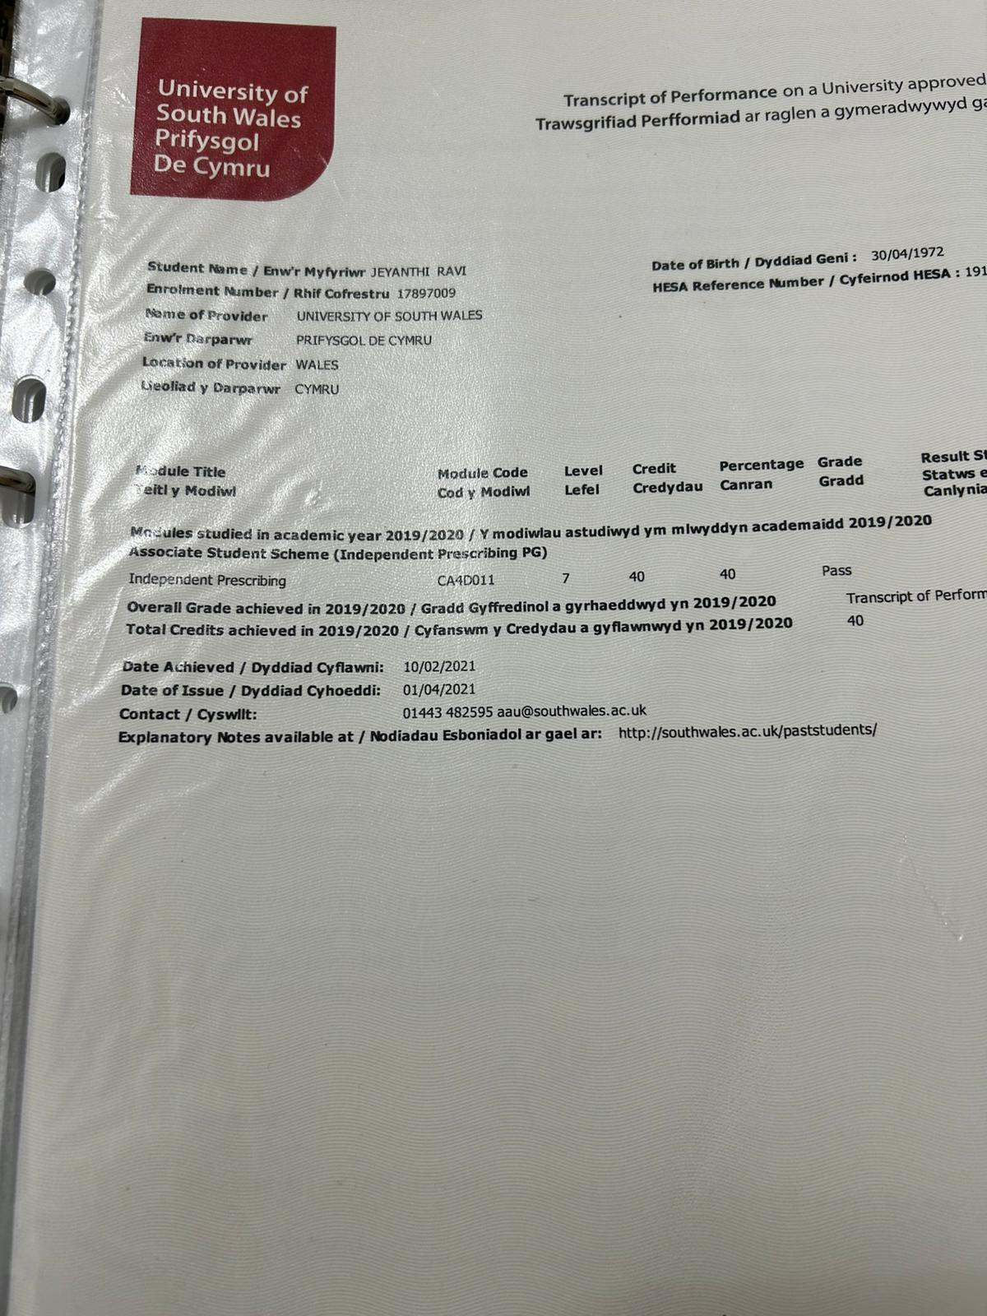

Proof of postgrad diploma SCP
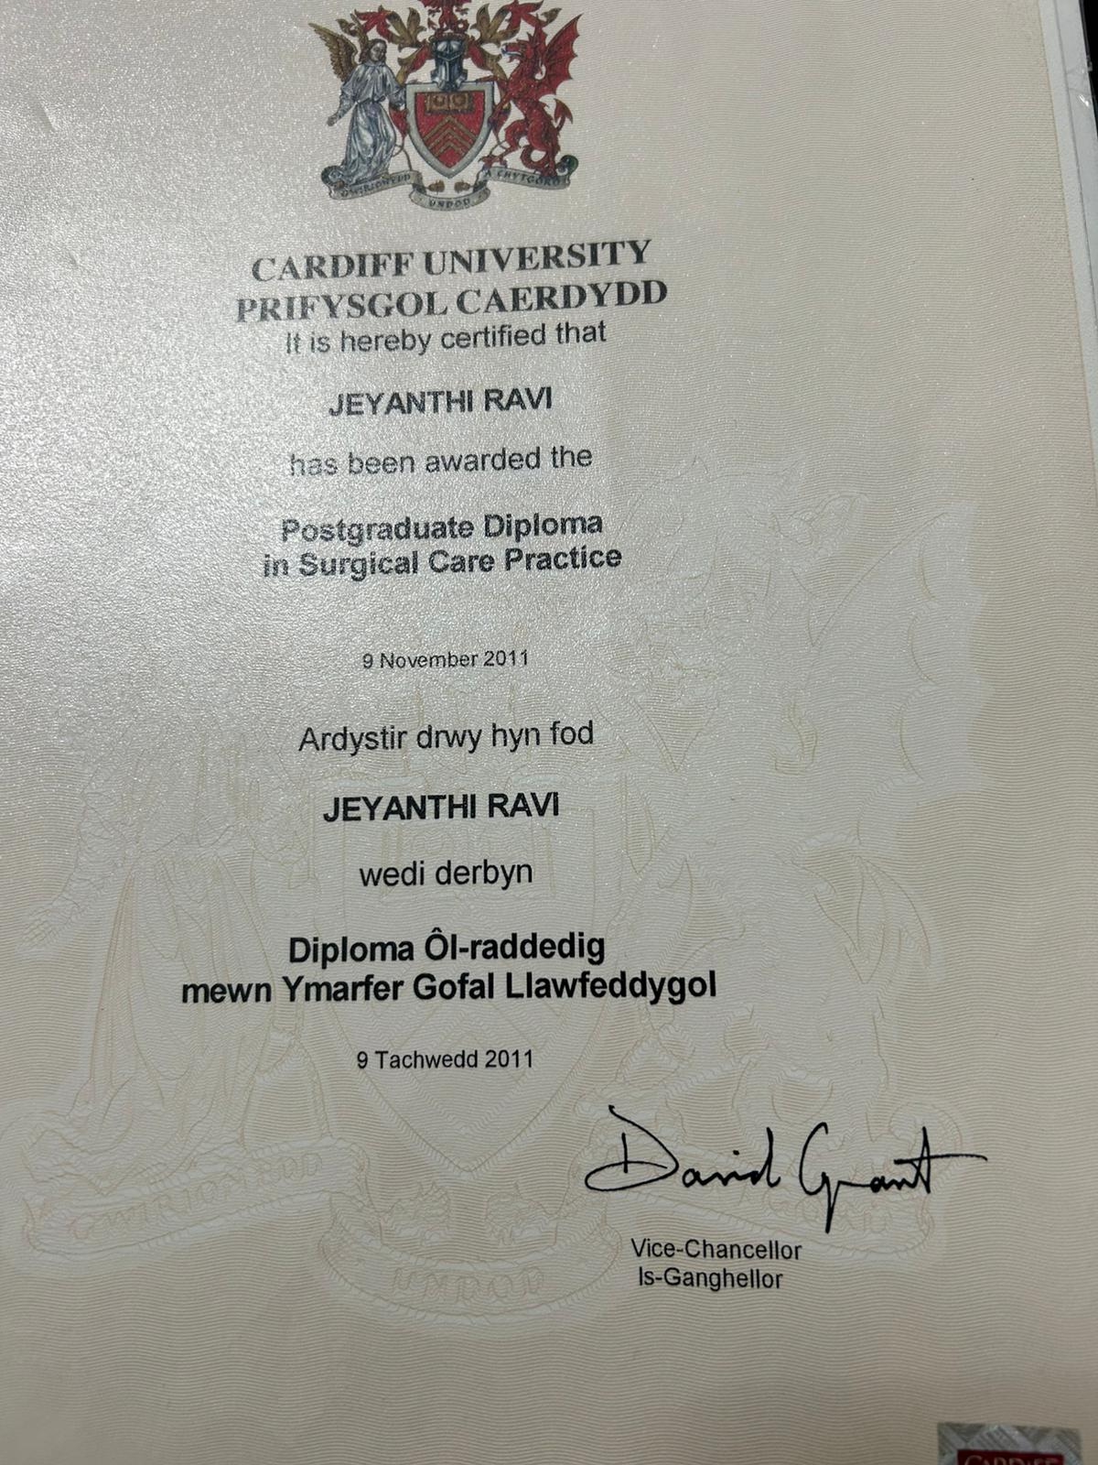

Proof of Masters
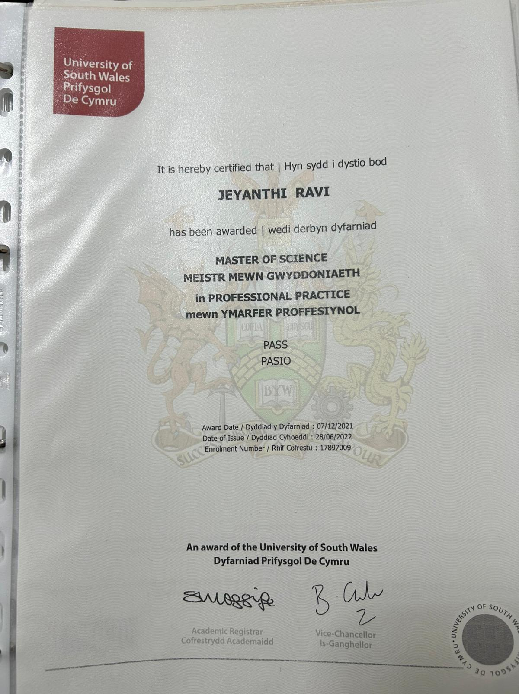

Nursing qualification
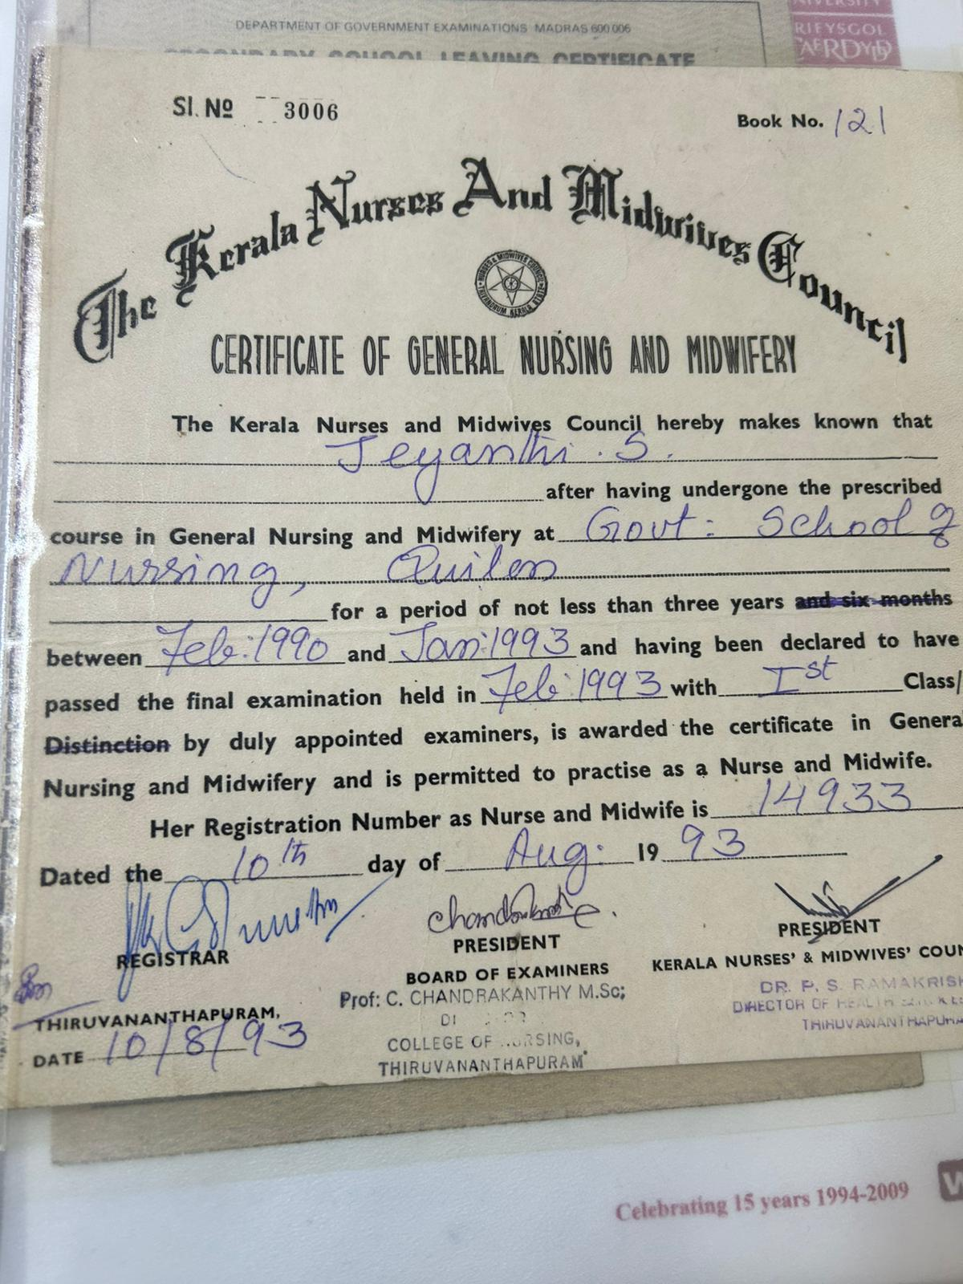

Testimonial from patient
Please accept this testimonial for Jeyanthi Ravi written on behalf of my husband Michael Szymanski and myself.

Jeya, possesses all the qualities and attributes that make her one of the most exceptional nurses that either of us have ever met.
The care and attention my husband received from her was outstanding and we will never forget this. She is a credit to her department, to nursing and to the NHS.
My husband and I first met her for his very detailed preoperative assessment for radical robotic prostatectomy for prostate cancer.
From the start of the assessment she was kind, compassionate and patient. She took her time to answer all the questions we had. Jeya had an abundance of knowledge and everything she did including taking bloods and ECG which were not usually part of her duties were done so very professionally.
The diagnosis of cancer is one that leaves a patient and loved ones feeling frightened, overwhelmed and not in control of their situation and Jeya gave us tremendous confidence and took the burden of worry away. Although always maintaining her professionalism she felt like a friend championing our situation.
It was a great relief for us to know that she would be there with my husband pre and post-operatively and she very kindly reassured me after the surgery that all was well.
Although everything has run smoothly after the operation Jeya has always been happy to be available to advise with any worries or concerns although this is not really part of her duties.

Her professionalism is of the highest level and in conjunction with her compassion, kindness and empathy she is someone whose calling is truly vocational.

Dr Alina McGarrigle
St David's

